MAC OS X


To access the System Preferences (Control panel on a PC) you click on the apple icon in the upper left hand corner and go down to System Preferences.

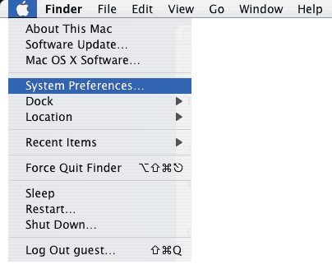

When you are in System Preferences the guest will see the following.
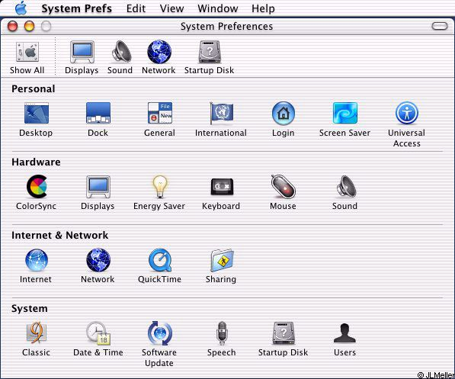
Have the guest click on the Network Icon and they will see the following.

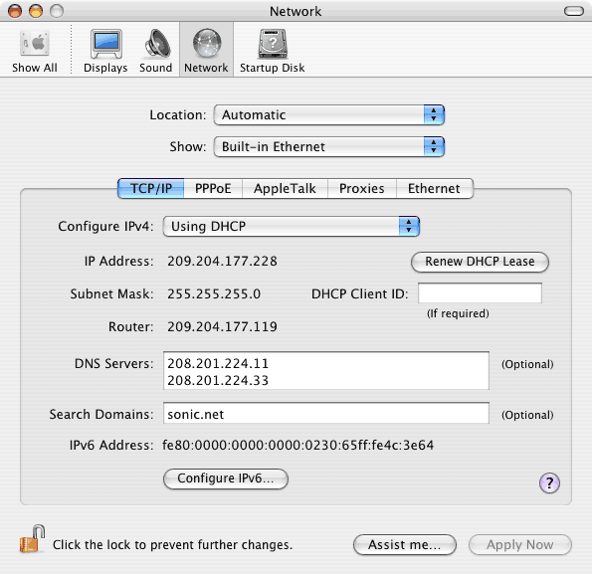
TCP/IP Tab

The location needs to be set at auto. Under the show drop down it needs to be set to Built-in Ethernet or Airport depending on what type of connection is available at the hotel. The first one type of connection that we will go over is the Built-in Ethernet.

On this screen there is only really one thing that you need to pay attention to. Configure IPv4 needs to be set for Using DHCP.
Proxies Tab

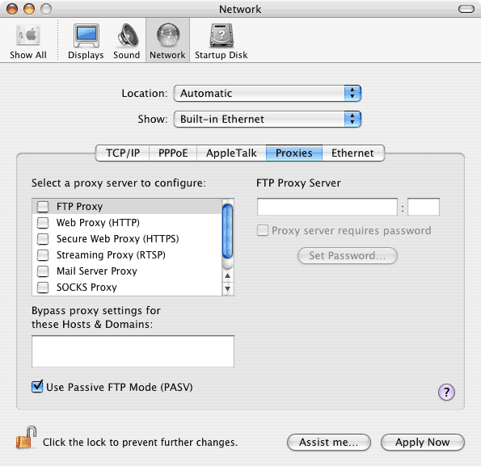

On this Tab you can find if the guest is using a proxy.

*Remember if you have a guest change ANY setting on their system then you need to Have them write down what the change is and how they can get back to where the change was made.

Ethernet Tab

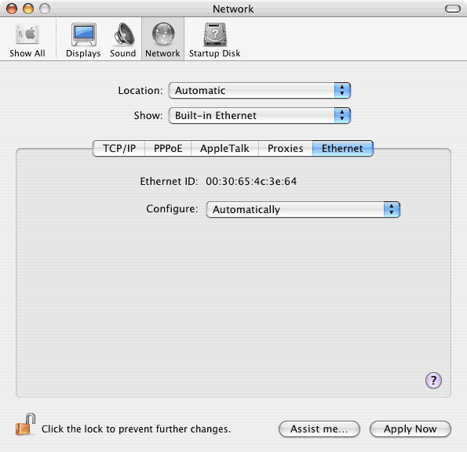

On this tab you can find the MAC address of the network card. Also Configure should be set to Automatically.

Airport (wireless)

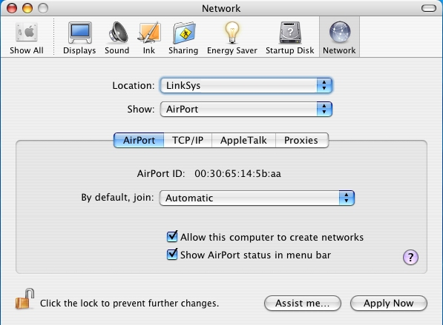

Airport Tab

The AirPort ID is the MAC address of the wireless card. If a guest is not automatically connecting to the wireless network then check this tab to make sure they do not have their AirPort card set to join a specific network. The box needs to NOT be checked for Allow this computer to create networks. (This is for AdHoc mode and if this box is check it will not work with an infrastructure network)

The TCP/IP and Proxy Tabs needs to be set up just like for Built-in Ethernet

